**Chapter 3 cont….**

* **CSS Flexbox flex item properties**
* Flex-direction
* Align-items to centre, right and left
* Wrap
* Collapse, etc,.
* **Bootstrap Grid System Part I**
* Containers
* Responsive breakpoints usage
* All the CSS flex item properties implementation.
* Usage of grid rows and cols.
* **Bootstrap Grid System Part II**
* Aligning the cols in rows.
* Manipulating height and width.
* Aligning methods like between, around, etc,.

**Chapter 4**

* **Project I -Pure Bootstrap Project**
* Project overview
* Project step by step process understanding
* Making modules like navbar, banners, photo management, cards , etc,.
* Done navbar(dropdown, search bar,etc,.) and banner for a responsive website for all breakpoints like xs, sm, md, lg.

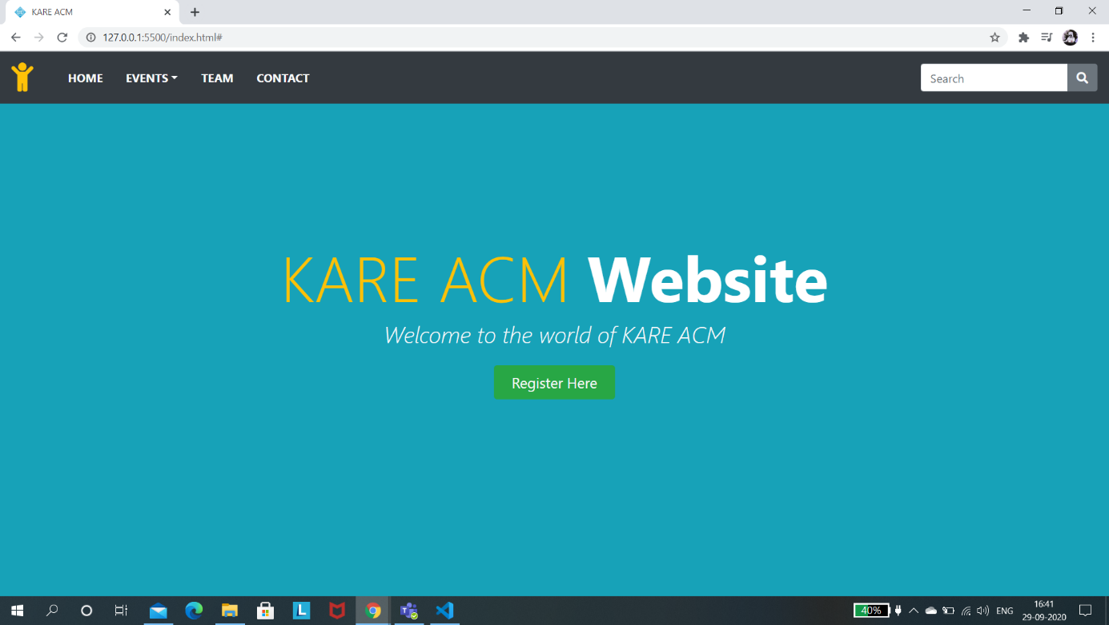

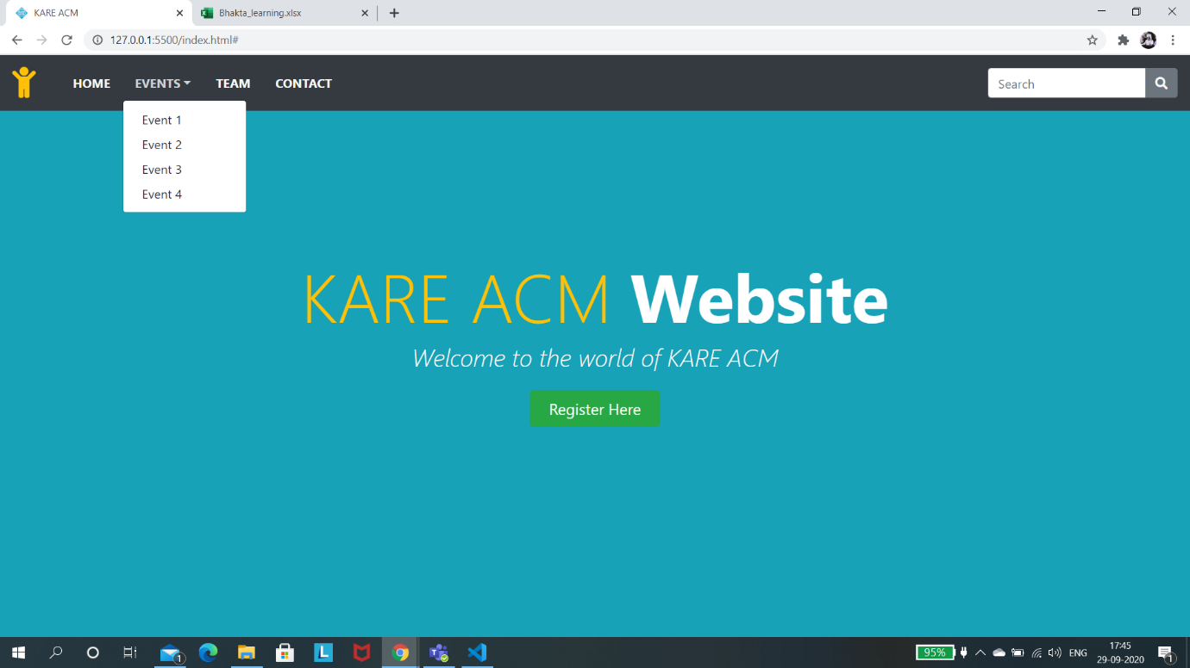

**Responsive Breakpoint “md”:**

